**ASSIGNMENT 10 – Building React Native Application with API**

**Code :**

<https://github.com/hemapunniakotti/ReactProjects/tree/main/Assignment10_FoodAppReactNative>

**Steps :**

We need to create the next folders

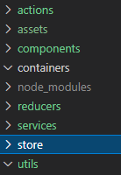

And we need to have our db.json running with the command: json-server --watch db.json --port 7000

We need to install on npm this packages

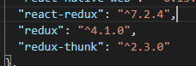

Then we create our reducers, actions, containers, etc. for redux.

**Output :**

Here we have our food app with all the food

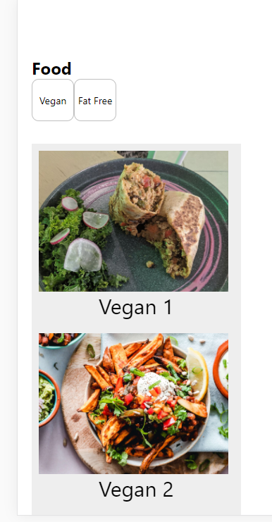

And we can filter the food with the buttons

